The Last Symphony

Designed and Developed By: -

Abani Bhusan Das

Sonu Shivhare

Priyanka Wakchaure

Description

Symphony of The Night is a 2D Platformer Action-Adventure game where the player takes control of a 19-year-old village boy names Trevor

The scene of the game is set to medieval time village period when there were lords who ruled vast across lands.

The game will consist of five levels, Village, Dark Forest, Lord’s Castle, Dungeon, Prison.

Five boss battles are present which takes place in Dark Forest, Dungeon and Prison.

Symphony of The Night is made using Unity3D with a 2D viewport, and the assets were collected from the asset store

Gameplay

1. Goal

The goal of the player in this game is to save the village from total destruction cause by the symphony (explained in the plot) and uncover secrets.

1. Player

The user takes control of this Villager who goes by the name of Trevor Vistok.

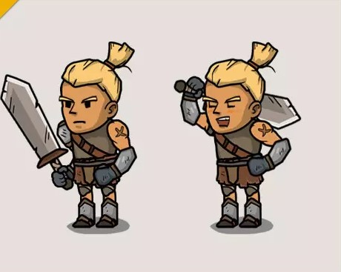

1. Enemies

There are two classes of enemy present.

The normal ones and the bosses.

The normal enemies are Scarecrows made from haystacks

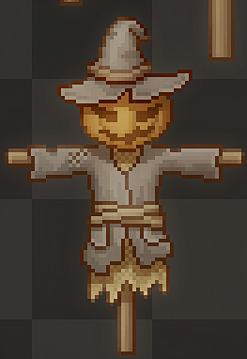

The Bosses who are Demons straight from damnation.

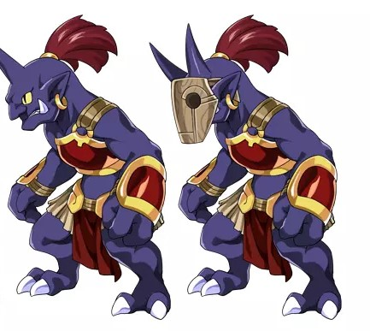

1. Controls

The player is provided with A and D and LEFT and RIGHT arrow keys for moving left and right

SPACEBAR for Jump

LCTRL to attack with Melee Weapon

LSHIFT to attack with Long Range Weapon.

1. Music and Sound

There will a somber background music for each level and piano based tune is selected.

Melee attacks will have sound effects.

Enemies will have zombie like sound.

Bosses will have their own music and different sounds

World Design

The initial level starts with outskirts of the village where Trevor lives.



Progress

Plot is completely prepared

Assets are chosen. Only few of the boss assets are pending

Controller of the game character has been prepared. A few modifications are required

The primary level has been set. A Few Modifications are required

Second Level “The Village” World Design is completed

Third Level, “Dark Forest” on progress.

Background is being changed constantly to check which suits better